2018
IBM Systems Technical Universities

Highlight on
z/OS for Rookies track Built for you!

21-23 August 2018, São Paulo

Every new IT generation which enters the workforce provides an opportunity to bring new skills into your IBM Z team. Performance and capacity teams are a mission-critical function, and keeping skills fresh in your organization will keep you on track.
Send your early career IBM Z programmers and engineers to the new track, z/OS for Rookies, at upcoming IBM Systems Technical Universities in Orlando and London.
This full week of sessions helps your newer team members to get started and go deep on IBM Z with hands-on training delivered by IBM Technical Training Instructors. But that’s not all.
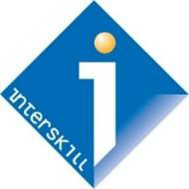
We are partnering with Interskill to offer 53 e-learning courses targeted at the Rookies track attendees. These Interskill courses are available at no additional charge, from the time you register for TechU to three months after the event.

Packed with a punch
The z/OS for Rookies track offers a full track of in-depth training sessions and labs delivered on-site at TechU combined with a self- paced e-learning curriculum.

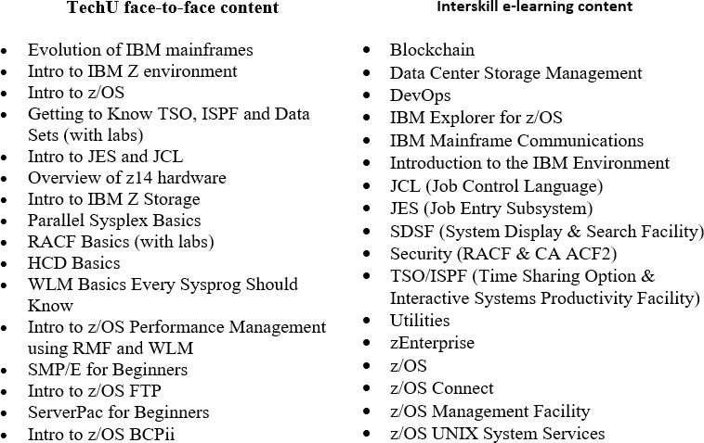

Comprehensive technical training for IT practitioners.

Brought to you by
IBM Systems Lab Services

Enroll today
- Explore the agenda and register for São Paulo now

Check out the Rookies e-learning curriculum To access the Rookies e-learning curriculum, please first register for TechU. Look for the question while registering to signal your interest in the z/OS for Rookies track.  - São Paulo – IBM TechU – August 21-23 Interskill courses available thru July 31, 2018. Register for São Paulo now  Who should attend the z/OS for Rookies track? This track was developed for a beginner’s skill level for the following IT roles working on IBM Z:  - Programmers  - Engineers  - Architects  - Administrators  - Specialists  Earn IBM Open Badges Earn IBM Open badges for these critical skills:  - Mainframe Specialist – SDSF  - Mainframe Specialist - z/OS UNIX System Services  - Mainframe Specialist - Mainframe Utilities and VSAM  - Mainframe Security Administrator - RACF – Expert  - Mainframe Specialist - Z Mainframe Infrastructure Awareness  - Blockchain Foundations  IBM TechU LinkedIn Group bit.ly/IBMTechUconnect  View event highlights – Connect with attendees and tech experts – Stay on top of the latest technology trends. Articles and more!  Questions? Email us at vilella@br.ibm.com  Looking for worldwide TechU events? ibm.com/training/events | Registration information  SãoPaulo - IBM Technical University  Ibm.biz/techusp2018  Registration Rates*  Business / Government / Business Partners  - Early Bird rate R$ 3.300 (ends 20 july)  - Standard rate R$ 4.500  The TechU will take place at the Hotel Taua Atibaia SP  http://www.tauaresorts.com.br/atibaia  Please note that you are responsible for your hotel booking and that your hotel reservation is not part of your registration to the conference.  .
IBM, the IBM logo, ibm.com, AIX, IBM Z, POWER9, Power Systems and z14 are trademarks of IBM Corp., registered in many jurisdi ctions worldwide. Other product and service names might be trademarks of IBM or other companies. A current list of IBM trademarks is available on the Web at “Copyright and trademark information” at: ibm.com/legal/copytrade.shtml. Published dates and locations are subject to change at any time © 2018 IBM Corporation. All
rights reserved.
